Chat with Retail Documents (RAG)
Manufacturing Operational Insights Report

  - Course Name : Generative AI

Institution Name: Medicaps University – Datagami Skill Based Course

Sr no | Student Name | Enrolment Number
1. | ADITYA AGRAWAL | EN22IT301006
2. | ATHARV SHUKLA | EN22IT301025
3. | VERMA NIKHIL KUMAR VIPIN KUMAR | EN23IT3L1002
4. | MALYA SINGH | EN24CA5030092
5. | MOHIT GUPTA | EN21CA301036

Group Name: Group 03D12
Project Number: GAI-41
Industry Mentor Name: Mr. Yash
University Mentor Name: Ajaj khan
Academic Year:2025-2026

Problem Statement & Objectives

Problem Statement
In the retail industry, organizations generate and manage a large volume of unstructured documents such as product manuals, policy documents, invoices, customer support guides, and operational reports. These documents contain valuable information, but extracting relevant insights from them is often a challenging and time-consuming task. Employees or users typically rely on manual search or basic keyword-based systems, which fail to capture the actual context of a query. As a result, users may receive incomplete or irrelevant information, leading to inefficiencies and poor decision-making.
Traditional search systems do not understand the meaning or intent behind a query, making them unsuitable for complex information retrieval tasks. For example, if a user asks a question about a return policy, a keyword search might return multiple unrelated sections instead of a precise answer. This increases the effort required to locate accurate information and reduces productivity. Additionally, with the increasing volume of documents, it becomes impractical to manually review each file.
To address these challenges, there is a need for an intelligent system that allows users to interact with documents using natural language. The system should be capable of understanding the query, retrieving relevant information, and generating precise answers based only on the provided documents. This ensures reliability and reduces hallucination. The proposed solution leverages Retrieval-Augmented Generation (RAG) to combine semantic search with advanced language models, enabling efficient and context-aware document intelligence for the retail domain.

Project Objectives

The primary objective of this project is to design and develop an intelligent Retail Document Intelligence system using Retrieval-Augmented Generation (RAG) that enables efficient and accurate information retrieval from unstructured documents. The system aims to allow users to upload various types of retail documents such as PDFs, reports, and manuals, and interact with them using natural language queries. One of the key objectives is to improve the overall search experience by replacing traditional keyword-based search with semantic search, which understands the meaning and intent of user queries.
Another important objective is to ensure that the system provides context-aware responses that are strictly grounded in the uploaded documents. This helps in minimizing hallucination, which is a common issue in large language models. The project also focuses on optimizing performance by reducing query response time and improving retrieval accuracy. Scalability is another key objective, ensuring that the system can handle large volumes of documents and multiple user queries efficiently.
Additionally, the system aims to provide a user-friendly interface that allows seamless interaction with documents in a conversational format. The use of embeddings and vector databases ensures efficient storage and retrieval of document data. Overall, the project seeks to demonstrate the practical application of Generative AI in the retail sector, enhancing productivity, reducing manual effort, and enabling faster decision-making through intelligent document querying.

Scope of the Project

The scope of this project focuses on building a robust and efficient system for document-based question answering in the retail domain using Retrieval-Augmented Generation. The project includes the complete pipeline starting from document ingestion to answer generation. It covers functionalities such as uploading documents, extracting text, processing and splitting the text into manageable chunks, generating embeddings, and storing them in a vector database. The system also includes a retrieval mechanism that fetches relevant document chunks based on user queries and a Large Language Model that generates answers using the retrieved context.
The project is designed to handle text-based documents such as PDFs, reports, and manuals commonly used in retail operations. It includes the development of a simple frontend interface where users can upload documents and interact with the system through a chat-based interface. The backend handles all processing tasks, including embedding generation, similarity search, and response generation.
However, the scope of the project is limited in certain areas. It does not include advanced features such as real-time collaborative editing of documents or support for multimedia data like images, audio, or video. The system is also not designed for highly domain-specific fine-tuning of models but instead relies on pre-trained models. Enterprise-level security features and large-scale distributed deployment are also beyond the current scope. Despite these limitations, the project effectively demonstrates the core concepts and implementation of a RAG-based system for intelligent document interaction.

Proposed Solution

- Key features

- Document upload functionality supporting various formats such as PDFs, manuals, and reports
- Semantic search capability using vector embeddings for improved relevance
- AI-powered question answering system for intelligent information retrieval
- Context-aware response generation using Retrieval-Augmented Generation (RAG) architecture
- Efficient and fast information retrieval from large document collections
- Natural language query processing for intuitive user interaction
- Text chunking and embedding generation for optimized data handling
- Integration with vector databases such as FAISS or Chroma
- Interactive chat-based user interface for seamless communication
- Secure document storage and data handling mechanisms
- Scalable system architecture to support large datasets and multiple users
- Metadata-based filtering for refined search results
- Reduction of hallucination through context-grounded responses
- API-driven backend for flexible integration and extensibility
- Performance optimization using caching and efficient retrieval techniques

- Overall Architecture / Workflow

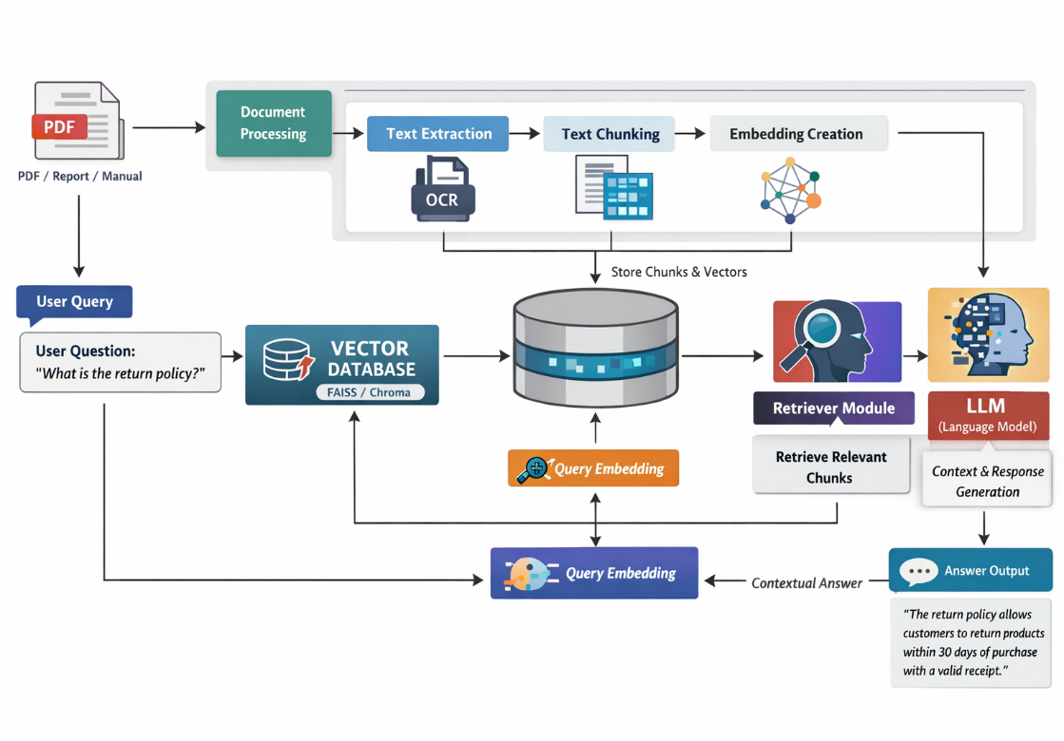
- Tools & Technologies Used

- Python: Python is used as the primary programming language for developing the backend of the application due to its simplicity, extensive libraries, and strong support for AI and machine learning frameworks. It enables efficient handling of APIs, data processing, and integration with various AI models.
- FastAPI: FastAPI is utilized to build the backend RESTful APIs. It provides high performance, automatic API documentation, and easy handling of asynchronous requests, making it ideal for serving AI-based applications.
- Uvicorn: Uvicorn acts as the ASGI server that runs the FastAPI application. It ensures fast execution, supports asynchronous communication, and enables smooth interaction between the frontend and backend.
- Groq API (LLM Integration): The Groq API is used to integrate Large Language Models (LLMs) into the system. It processes user queries and generates intelligent, context-aware responses based on retrieved documents.
- LangChain: LangChain is used to build the Retrieval-Augmented Generation (RAG) pipeline. It helps in chaining together different components such as document loaders, embeddings, retrievers, and LLMs for efficient query processing.
- ChromaDB: ChromaDB is employed as the vector database to store document embeddings. It enables fast similarity search and retrieval of relevant documents based on user queries.
- Sentence Transformers: This library is used to convert textual data into vector embeddings. These embeddings help in measuring semantic similarity between user queries and stored documents.
- FAISS (Optional Alternative): FAISS can be used as an alternative vector store for efficient similarity search. It is optimized for handling large-scale embedding data.
- HTML, CSS, JavaScript: These technologies are used to design and develop the frontend interface. HTML structures the content, CSS enhances visual appearance, and JavaScript handles dynamic interactions and API communication.
- Fetch API: The Fetch API in JavaScript is used to send HTTP requests from the frontend to the backend, enabling real-time communication and response display.
- Virtual Environment (venv): A virtual environment is used to manage project dependencies in isolation, ensuring that required libraries are installed without affecting the global Python setup.

Results & Output
- Screenshot


- Reports / dashboards / models
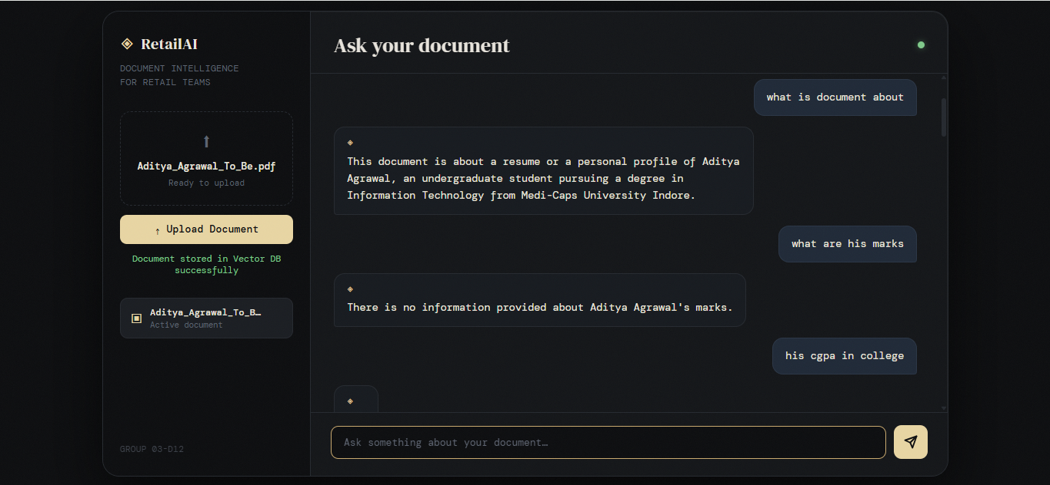
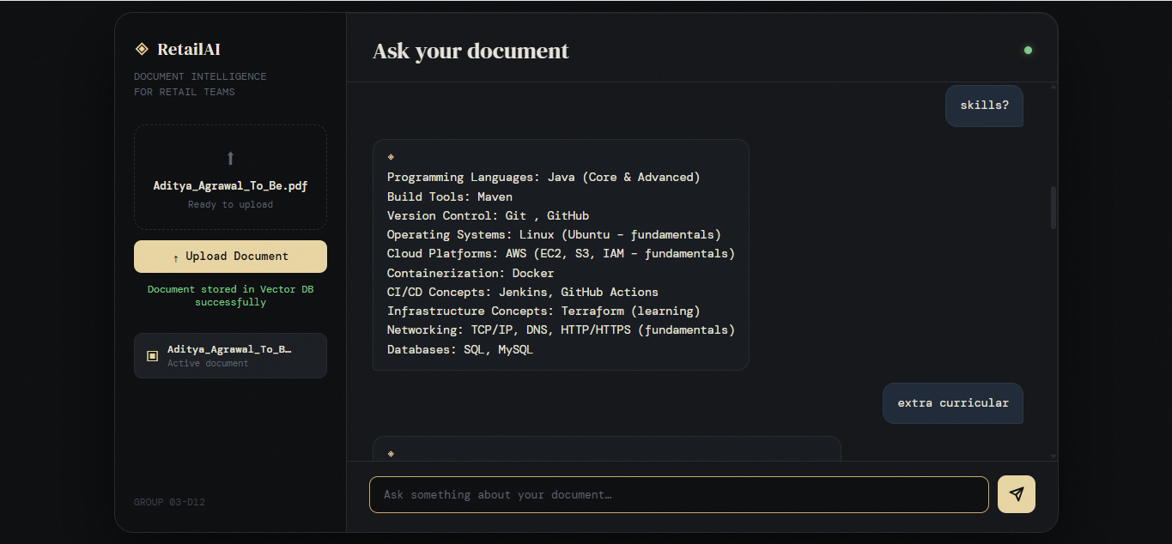

- Key outcomes

- To Develop an Intelligent Document Query System
The primary objective of this project is to design and develop an AI-powered system that allows users to interact with retail documents using natural language queries. Instead of manually searching through large volumes of data, users can simply ask questions and receive relevant answers instantly, improving accessibility and usability.
- To Implement Retrieval-Augmented Generation (RAG)
The project aims to integrate a RAG-based architecture that combines document retrieval with response generation. This ensures that the system first fetches relevant information from stored documents and then uses a language model to generate accurate and context-aware responses, enhancing the overall quality of outputs.
- To Enable Semantic Search Capabilities
Another key objective is to move beyond traditional keyword-based search and implement semantic search using vector embeddings. This allows the system to understand the meaning and context of user queries, resulting in more relevant and precise information retrieval.
- To Utilize Advanced Language Models (LLMs)
The system is designed to leverage Large Language Models to generate human-like, coherent, and contextually appropriate responses. This improves user interaction and makes the system more intuitive and conversational.
- To Build a Scalable and Modular Architecture
The project focuses on creating a modular system where components such as the backend API, vector database, and frontend interface can be independently updated or replaced. This ensures scalability and flexibility for future enhancements.
- To Provide a User-Friendly Interface
An important objective is to design a simple and interactive frontend that allows users to easily input queries and view responses. The goal is to ensure a seamless and efficient user experience.
- To Ensure Efficient Data Handling and Storage
The system aims to efficiently process, store, and retrieve document data using vector databases. Proper data handling ensures faster query responses and optimized performance.
- To Demonstrate Real-World Application of AI Technologies
The project serves as a practical implementation of modern AI concepts such as RAG, embeddings, and LLMs, showcasing their application in solving real-world problems in the retail domain.
- To Improve Decision-Making and Productivity
By providing quick and accurate access to relevant information, the system helps users make informed decisions faster, thereby increasing overall productivity.

Conclusion
The Retail Document Chatbot developed using a Retrieval-Augmented Generation (RAG) approach successfully demonstrates the integration of modern artificial intelligence techniques to solve real-world problems. The system effectively enables users to interact with large volumes of retail documents through natural language queries, eliminating the need for manual searching and significantly improving efficiency. By combining semantic search with advanced language models, the chatbot ensures that responses are not only accurate but also contextually relevant and easy to understand.
The use of vector embeddings and a vector database enhances the system’s ability to retrieve meaningful information based on intent rather than simple keyword matching. Additionally, the modular architecture, consisting of a FastAPI backend and a user-friendly frontend, ensures scalability, flexibility, and ease of maintenance. The implementation also highlights the practical application of technologies such as embeddings, LLMs, and API-based communication in building intelligent systems.
Overall, the project achieves its objective of creating an efficient, scalable, and intelligent document querying system. It improves information accessibility, reduces time consumption, and enhances user experience. This solution can be further extended to various domains beyond retail, making it a valuable and versatile AI-driven application.

Future Scope & Enhancements

- Integration of Advanced Language Models
The system can be enhanced by integrating more advanced and fine-tuned Large Language Models to improve response accuracy, contextual understanding, and domain-specific knowledge. This would enable more precise and intelligent interactions with complex retail documents.
- Support for Multiple Data Formats
Future improvements can include the ability to process various document formats such as PDFs, Word files, Excel sheets, and even images. This will make the system more versatile and capable of handling diverse retail data sources.
- Implementation of a Full-Fledged Dashboard
A comprehensive dashboard can be developed to visualize user queries, response times, system performance, and analytics. This would help administrators monitor usage patterns and improve system efficiency.
- User Authentication and Personalization
Adding user login and authentication features can enhance security. Personalization can be introduced by storing user preferences and providing customized responses based on user history.
- Real-Time Data Integration
The system can be extended to fetch and process real-time data from external APIs or databases. This would ensure that users receive up-to-date and dynamic information.
- Improved Retrieval Techniques
Advanced retrieval methods such as hybrid search (combining keyword and semantic search) or re-ranking algorithms can be implemented to further enhance the accuracy of retrieved results.
- Scalability with Cloud Deployment
Deploying the application on cloud platforms can improve scalability, availability, and performance. It would allow the system to handle a large number of users and large-scale data efficiently.
- Voice-Based Interaction
Future versions can include speech-to-text and text-to-speech capabilities, enabling users to interact with the system using voice commands for a more natural experience.
- Multilingual Support
The chatbot can be enhanced to support multiple languages, making it accessible to a wider audience and improving usability in diverse regions.
- Enhanced Security Measures
Implementing data encryption, secure APIs, and role-based access control can ensure better protection of sensitive retail data.
- Feedback and Continuous Learning Mechanism
A feedback system can be introduced where users can rate responses. This data can be used to continuously improve the model’s performance over time.
- Mobile Application Development
Developing a mobile app version of the system can increase accessibility and provide users with a convenient platform to interact with the chatbot anytime and anywhere.

